A CASE STUDY ON:

**Microstrip Antenna Feeding Techniques**

SUBMITTED BY:

|  |  |  |
| --- | --- | --- |
| Sr No. | Name of Students | SAP |
| 1. | Maitriya Y. Damani | 60002160014 |
| 2. | Bhargav S. Desai | 60002160017 |
| 3. | Viren Baria | 60002160005 |
| 4 | Sanjeet Krishna | 60002160050 |

Name of Guide: Prof. Ranjushree Pal

CERTIFICATE

This is to certify that Master **Viren Baria**, SAP ID: **60002160005** of **TE EXTC 1** has submitted their Mini Project for Antenna & Wave Propagation Lab for the Academic Year 2019-2020

Guide Examiner

Head of Department

Index

|  |  |  |
| --- | --- | --- |
| Sr. No. | Particulars | Page No. |
| 1. | Introduction | 4 |
| 2. | Working Principle | 5 |
| 3. | Types of Feeding Techniques | 6 |
| 4. | Comparison of Techniques | 14 |
| 5. | Conclusion | 14 |
|  |  |  |

Introduction

Microstrip or patch antennas are becoming increasingly useful because they can be printed directly onto a circuit board. Microstrip antennas are becoming very widespread especially within the mobile phone market.

Patch antennas are low cost, have a low profile and are easily fabricated and mounted on a flat surface. They have a two dimensional physical geometry.



The simplest patch antenna uses a patch which is one-half wavelength long, so that the metal surface acts as a resonator similarly to the half-wave dipole antennas.

A patch antenna is usually fabricated by mounting a shaped metal sheet on an insulating dielectric substrate, such as a printed circuit board, with a continuous metal layer bonded to the opposite side of the substrate which forms a ground plane. Hence it is easy to design and inexpensive to manufacture. Some patch antennas do not use a dielectric substrate and instead made of a metal patch mounted above a ground plane using dielectric spacers. The resulting structure is less rugged but has a wider bandwidth.

The reason why patch antennas are so powerful and widespread is because of a very simple reason, that they can be designed from the Ultra High Frequency bandwhich is from around 300 MHz to as high as 100 GHz all with the antennas designedpractically fitting in the palm of your hand.

Working Principle:

Before we come to the feeding techniques, let us discuss a bit about a microstrip antenna’s working principle and answer the question of how is it actually, that a microstrip antenna radiates.

The fringing fields around the antenna can help explain why the microstrip antenna radiates. Consider the side view of a patch antenna, shown below:

The current at the end of the patch is zero and the current is maximum at the centre of the half-wave patch.

Now since, the patch antenna can be viewed as an open circuited transmission line, the voltage reflection coefficient will be 1.

When this occurs, the voltage and current are out of phase.

Hence, at the end of the patch the voltage is at a maximum (say +V volts). At the start of the patch antenna (a half-wavelength away), the voltage must be at minimum (-V Volts). Hence, the fields underneath the patch will resemble, which roughly displays the fringing of the fields around the edges.

Note that the fringing fields near the surface of the patch antenna are both in the +y direction. The fringing E-fields on the edge of the microstrip antenna add up in phase and produce the radiation of the microstrip antenna.

Consequently, the microstrip antenna's radiation arises from the fringing fields, which are due to the advantageous voltage distribution.

Hence the radiation arises due to the voltage and not the current. The patch antenna is therefore a "voltage radiator", as opposed to the wire antennas, which radiate because the currents add up in phase and are therefore "current radiators”.

Types of Feeding Techniques

The four most popular feed techniques used are the microstrip line, coaxial probe (both contacting schemes), aperture coupling and proximity coupling (both non- contacting schemes).

So, the various types of feeding techniques that we will discuss are below:

1. Microstrip Line
2. Coaxial Probe
3. Aperture Coupling
4. Proximity Coupling

**1. Microstrip (Offset Microstrip) Line Feed**

In this type of feed technique, a conducting strip is connected directly to the edge of the microstrip patch as shown in figure 1.2. The conducting strip is smaller in width as compared to the patch. This kind of feed arrangement has the advantage that the feed can be etched on the same substrate to provide a planar structure. An inset cut can be incorporated into the patch in order to obtain good impedance matching without the need for any additional matching element. This is achieved by properly controlling the inset position.

Consider the following representation:

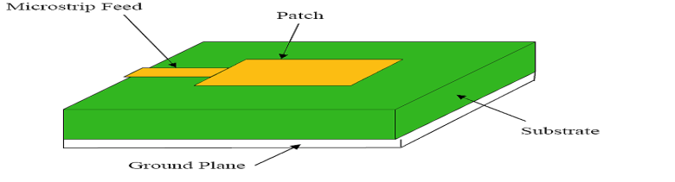

Hence this is an easy feeding technique, since it provides ease of fabrication and simplicity in modelling as well as impedance matching. However as the thickness of the dielectric substrate increases, surface waves and spurious feed radiation also increases, which hampers the bandwidth of the antenna.

We summarise the feeding technique in the form of the table below:

| Advantages | Disadvantages |
| --- | --- |
| It is a easy feeding technique | Results in undesirable cross polarization effects. |
| Provides ease of fabrication | Increase in surface waves |
| Impedance matching | Increase in spurious radiation |
| Simplicity in modelling | Undesirable cross polarisation |

**2. Coaxial Feed**

The Coaxial Feed or Probe Feed is one of the most common techniques used for feeding microstrip patch antennas.

Consider the following figure:

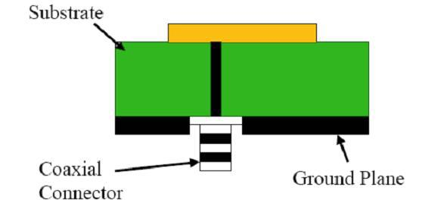

As seen from figure, the inner conductor of the coaxial connector extends through the dielectric and is soldered to the radiating patch, while the outer conductor is connected to the ground plane.

The main advantage of this type of feeding scheme is that the feed can be placed at any desired position inside the patch in order to obtain impedance matching. This feed method is easy to fabricate and has low spurious radiation effects. However, its major disadvantage is that it provides narrow bandwidth and is difficult to model since a hole has to be drilled into the substrate. Also, for thicker substrates, the increased probe length makes the input impedance more inductive, leading to matching problems. By using a thick dielectric substrate to improve the bandwidth, the microstrip line feed and the coaxial feed suffer from numerous disadvantages such as spurious feed radiation and matching problem. The non-contacting feed techniques which have been discussed below, solve these problems.

We summarise this feeding technique in the form of a table below:

| Advantages | Disadvantages |
| --- | --- |
| The Feed can be placed at any desirable position | Narrow bandwidth |
| Impedance matching can be obtained | Difficult to model |
| Easy to fabricate | For thicker substrates, the increased probe length makes the input impedance more inductive, leading to matching problems |
| Low spurious radiations | If substrate is thickened to increase bandwidth, spurious radiation will increase. |

**3. Aperture Coupled Feed**

In aperture coupling as shown in figure below, the radiating microstrip patch element is etched on the top of the antenna substrate, and the microstrip feed line is etched on the bottom of the feed substrate in order to obtain aperture coupling. The thickness and dielectric constants of these two substrates may thus be chosen independently to optimise the distinct electrical functions of radiation and circuitry. The coupling aperture is usually centered under the patch, leading to lower cross-polarisation due to symmetry of the configuration. The amount of coupling from the feed line to the patch is determined by the shape, size and location of the aperture. Since the ground plane separates the patch and the feed line, spurious radiation is minimised.

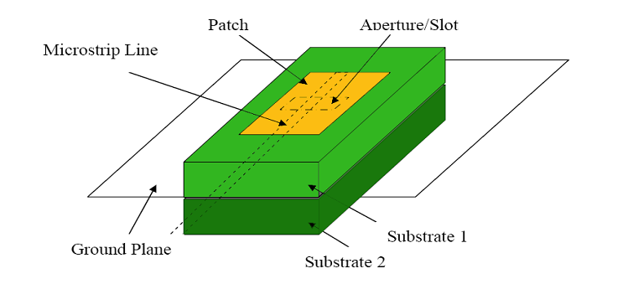

Generally, a high dielectric material is used for bottom substrate and a thick, low dielectric constant material is used for the top substrate to optimise radiation from the patch. This type of feeding technique can give very high bandwidth of about 21%. Also the effect of spurious radiation is very less as compared to other feed techniques. The major disadvantage of this feed technique is that it is difficult to fabricate due to multiple layers, which also increases the antenna thickness.

| Advantages | Disadvantages |
| --- | --- |
| Lower cross-polarisation | Difficult to fabricate due to multiple layers |
| Spurious radiation is minimised | Since it is difficult to fabricate, it obviously difficult to model. |
| Very high bandwidth. | Due to multiple layers, the thickness increases |

**4. Proximity Coupled Feed**

This type of feed technique is also called as the electromagnetic coupling scheme. As shown in figure below, two dielectric substrates are used such that the feed line is between the two substrates and the radiating patch is on top of the upper substrate. The main advantage of this feed technique is that it eliminates spurious feed radiation and provides very high bandwidth of about 13%, due to increase in the electrical thickness of the microstrip patch antenna. This scheme also provides choices between two different dielectric media, one for the patch and one for the feed line to optimise the individual performances.

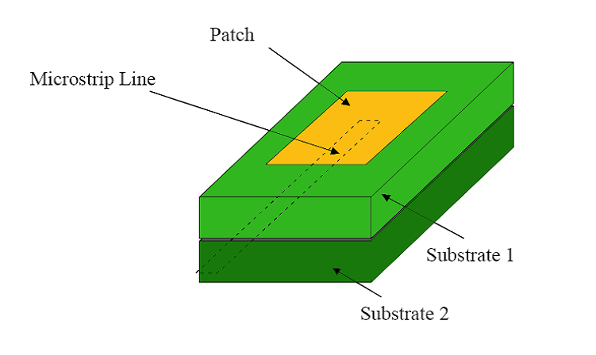

The major disadvantage of this feed scheme is that it is difficult to fabricate because of the two dielectric layers that need proper alignment. Also, there is an increase in the overall thickness of the antenna. The rapid progress in wireless communications promises to make interactive voice, data, and video services available anytime and anyplace. Wireless communication systems come in a variety of different sizes ranging from small hand-held devices to wireless local area networks. The desirable features of microstrip antennas, such as performance, flexibility, simplicity, high gain and low fabrication cost, make them very popular for many applications. The slot in the radiating element gives a more compact design for the antenna and, thus, space–volume is saved. Since then these methods, aperture coupling and proximity coupling have helped overcome several of the performance hindrances associated with direct contact excitation procedures (probe and edge feeding). These include the inherent narrow bandwidth of direct contact fed patches and also the spurious radiation associated with the current discontinuity where the feed and the patch join. Despite overcoming these detrimental attributes, proximity coupled patches have received little attention in the literature. This may be because the original form required an external impedance matching circuit to achieve a reasonable impedance bandwidth (approximately 13%). In a stacked proximity coupled patch was developed that displayed a broad impedance bandwidth of approximately 25%, however this was achieved with the assistance of slots within the patch radiators.

| Advantages | Disadvantages |
| --- | --- |
| The slot in the radiating element gives a more compact design for the antenna and, thus, space–volume is saved | Difficult to fabricate because of the two dielectric layers that need proper alignment. |
| Spurious radiation is minimised | Increase in thickness of antenna |

Comparison of Different Feeding Techniques

Conclusion

The preceding discussion in the case study explains and compares various coupling techniques with their advantages and disadvantages.

While the most desirable results seem to be given by Aperture Coupled Feeding, in the sense that it gives low spurious radiation, good reliability, and the best bandwidth of all (21%), the fabrication complexity also increases as a trade-off since there are multiple layers to be fabricated which also results in the increase of thickness.

Hence, we conclude that the decision as to which feeding technique has to be used is largely dependent on which use case we are using the antenna for.

References

1. **Antenna Theory: Analysis and Design, 4th Edition by Constantine A. Balanis**
2. [**www.antenna-theory.com**](http://www.antenna-theory.com)
3. [**www.allaboutradars.com**](http://www.allaboutradars.com)
4. [**www.howstuffworks.com**](http://www.howstuffworks.com)